Clinical Feature-Mapping Errors and Their Effects on Hospital Readmission Prediction: An Exploratory Study
Independent pilot study | November 2026

Abstract
A clinical feature can keep the same name and numeric type while carrying the wrong information after a data transformation. I explored this problem using the UCI Diabetes 130-US Hospitals dataset and a deliberately introduced error: exchanging inpatient and emergency visit counts in part of the training data. I compared a logistic regression model trained with correct mappings (E0), a model trained with the swap (E1), and a model trained after restoring the mapping (E2). On held-out test encounters, AUROC was 0.62086 for E0 and 0.62024 for E1; the patient-level bootstrap interval for their difference crossed zero. However, predictions changed unevenly. Encounters with four or more emergency visits had a mean absolute probability difference of 16.93 percentage points. This controlled pilot does not test real hospital transformations, but it shows why aggregate accuracy measures alone may miss prediction sensitivity to incorrectly mapped clinical variables.

1. Introduction
While working with healthcare data transformations, I kept coming back to a practical concern: a field can pass technical checks and still represent the wrong clinical information. In an outpatient data pipeline, mapping rules decide which source value becomes a downstream variable. A successful run tells us that the pipeline worked technically; it does not always tell us whether the final variable preserves the meaning of its source. That distinction is what led me to this experiment.
Consider prior inpatient and emergency visits. Both are counts, but they describe different kinds of care. If a transformation assigns emergency counts to an inpatient field, the values remain numeric and the column name can stay unchanged. A model trained on the resulting table would have no direct indication that the mapping was wrong. I wanted to see whether that seemingly ordinary processing mistake would alter what the model learns, and whether its effect would be visible in overall scores or mainly in particular predictions.
My longer-term interest is in clinical data that move through different systems and representations. Across institutions, similar feature names can hide different coding practices, source records, or derivation rules. I am especially interested in whether provenance, the record of where a value came from and how it was transformed, can help explain those differences. This pilot tackles only one small part of that question. I used an existing 30-day readmission outcome so I could measure the effects of a known mapping error; I did not perform a FHIR-to-OMOP conversion, collect provenance features, or train a federated model.

2. Research question
When inpatient and emergency visit counts are incorrectly assigned during training, how much does that change a model’s overall 30-day readmission performance and its predictions for individual encounters? I also examined whether changes were more pronounced among encounters with unusually high emergency utilization. The aim was to measure the response to one controlled error, not to assume in advance that performance would decline.

3. Methods

3.1 Dataset and splits
I used the publicly available UCI Diabetes 130-US Hospitals dataset, covering hospital encounters from 1999 to 2008. It contains 101,766 encounter records and 71,518 distinct patient identifiers. Because these records concern people with diabetes, I used the existing readmission outcome rather than trying to predict diabetes diagnosis. The binary label was 1 for readmission within 30 days (the original “<30” category) and 0 for other recorded outcomes. There were 11,357 positive encounters (11.16%). My predictors were eight numeric variables: number_inpatient, number_emergency, number_outpatient, time_in_hospital, num_medications, num_lab_procedures, num_procedures, and number_diagnoses. The initial audit found no missing values in these eight fields.
I assigned patients, not individual encounter rows, to the data splits. This mattered because 16,773 patients had more than one encounter; splitting by row could place the same person in both training and testing. With seed 2026, patient IDs were shuffled into three artificial clients, then divided approximately 70%/15%/15% within each client into training, validation, and test patients. This gave 71,197 training encounters, 15,250 validation encounters, and 15,319 test encounters, with no patient overlap across the groups. These clients are only experimental partitions: the dataset does not provide the hospital identifiers needed to treat them as separate observed institutions.

3.2 Experimental conditions and model
I defined three conditions before comparing models. In E0, the original inpatient and emergency values were used everywhere. In E1, I copied the training table and swapped number_inpatient with number_emergency for simulated Client 0 only. The two values differed in 8,482 of that client’s 23,820 training encounters; the other records and all outcome labels were left unchanged. Validation and test inputs always retained the correct mapping. In E2, I reversed the known swap and confirmed that the restored training data matched E0 exactly. This was an oracle-assisted restoration, not an automated way to detect incorrect mappings.
For each condition, I trained a fresh, pooled logistic regression model with the same settings (scikit-learn StandardScaler followed by LogisticRegression, max_iter=1000, random_state=2026). Scaling parameters were learned from the corresponding training data only. The pooled model is a simple controlled comparison, not federated learning. I used validation data to inspect AUROC, average precision (AUPRC), Brier score, and changes in individual predicted probabilities; the unchanged test set was reserved for final evaluation.
To check whether the E1 result depended on which patients received the error, I kept the original train/validation/test split fixed and reassigned training patients to three simulated clients using five more seeds (2027–2031). For each assignment, I applied the same swap to the newly designated Client 0, retrained E1, and compared it with the original E0 on the same validation records. Finally, on the held-out test set, I estimated percentile 95% intervals from 300 paired bootstrap samples drawn by patient, keeping all encounters of each resampled patient together. Models were not retrained during bootstrapping.

4. Results

4.1 Overall held-out performance
Metric | E0: Correct | E1: Incorrect | E2: Restored
AUROC | 0.62086 | 0.62024 | 0.62086
AUPRC | 0.19346 | 0.19065 | 0.19346
Brier score | 0.09607 | 0.09644 | 0.09607

E1 had slightly lower AUROC and AUPRC and a slightly higher Brier score than E0. E2 reproduced E0 predictions within the numerical tolerance used in the experiment. These observed aggregate changes were small.

4.2 Prediction differences for individual encounters
The aggregate scores did not tell the whole story. On the held-out test set, encounters with four or more emergency visits showed a mean absolute difference of 16.93 percentage points between E0 and E1 predicted probabilities, compared with 2.02 points for one to three visits and 0.64 points for zero visits. The high-utilization group contained 170 of the 15,319 test encounters. A change in predicted probability is not necessarily an error or a change in a clinical decision.
Emergency visits | Test encounters | Mean absolute change (pp)
0 | 13,593 | 0.64
1–3 | 1,556 | 2.02
4+ | 170 | 16.93

4.3 Repeated client assignments
I compared five additional E1 models with the fixed E0 baseline on the same validation records. Mean changes were -0.00060 for AUROC and -0.00234 for AUPRC. Each assignment produced a small decrease, although its size varied. Figure 1 focuses on the prediction changes: encounters with four or more emergency visits had consistently larger absolute differences than encounters with one to three visits.
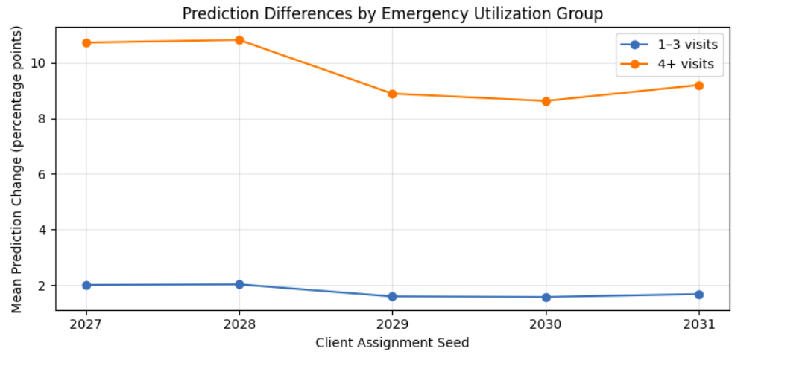
Figure 1. Mean absolute E0–E1 prediction difference across five simulated-client assignments. The 4+ emergency-visit group shows larger differences than the 1–3 visit group in every run. These are validation-set results; the zero-visit group is omitted from this figure for readability.
Across the five assignments, the average absolute change was 9.65 percentage points in the 4+ visit group, 1.77 points in the 1–3 visit group, and 0.48 points in the zero-visit group. The same validation encounters were reused, so these are descriptive comparisons across assignments rather than independent patient samples.

4.4 Bootstrap uncertainty
To assess the small test-set performance difference, I drew 300 bootstrap samples at the patient level, keeping encounters from the same patient together and applying each sample to both fixed models. The average bootstrapped AUROC difference (E1 minus E0) was -0.00064, with a percentile 95% interval from -0.00409 to +0.00287. Figure 2 places this interval against zero. Because the interval crosses zero, these data do not establish a consistent decline in AUROC.
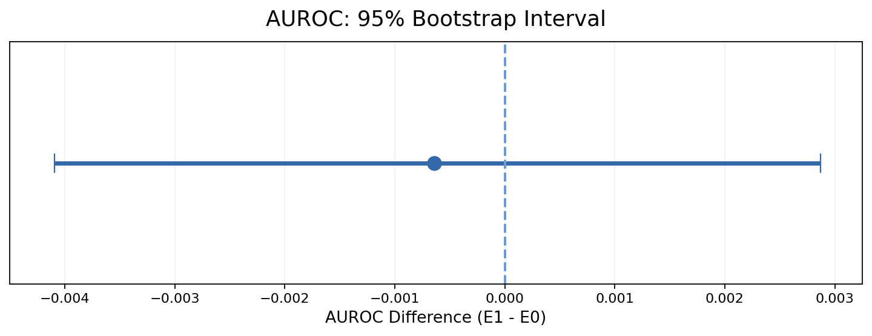
Figure 2. Patient-level bootstrap interval for the held-out AUROC difference (E1 − E0). The dot is the mean bootstrap difference and the horizontal bar spans the percentile 95% interval. The dashed vertical line marks zero difference.
The corresponding intervals were -0.00935 to +0.00328 for AUPRC and -0.00007 to +0.00082 for Brier score. All included zero. These intervals describe uncertainty for the fixed models and test-patient resampling, not variability from retraining new models or collecting data from other institutions.

5. Discussion and limitations
What surprised me was the gap between the overall scores and the individual predictions. The error reduced test AUROC by only 0.00062, and the bootstrap interval included zero. That is too little evidence to claim a reliable decline in aggregate performance. Yet some encounters received very different probability estimates. On the test set, the average absolute E0–E1 change was 16.93 percentage points among the 170 encounters with four or more emergency visits, compared with 0.64 points among encounters with none. These are changes between models, not measured clinical harms or proof that E1 is wrong for each person.
The fitted coefficients offer one possible explanation. The emergency-visit coefficient rose from 0.0205 in E0 to 0.1704 in E1, while the inpatient-visit coefficient fell from 0.2689 to 0.1916, expressed per original feature unit on the log-odds scale. E1 therefore learned a different relationship with these two utilization counts. Large emergency counts can amplify that difference, although the intercept, the other features, and extreme records also matter. The five reassignment experiments showed a similar ordering of prediction changes, but they used the same validation patients and do not establish population-wide stability.
For my broader research interest, the lesson is about the gap between a field’s technical validity and its clinical meaning. Here, the same column names and data types concealed a known source-to-target misassignment. In real multi-institutional data, the problem could be less obvious: two hospitals might both record an “active diagnosis,” while one derives it from a problem list and the other from recent encounter diagnoses. Differences in coding practices or time windows can be just as consequential. That is a broader form of semantic heterogeneity than the simple swap I tested. The experiment does not show that those real differences behave the same way, but it makes the downstream question concrete: if representations are not equivalent, what changes in model behavior might go unnoticed when we look only at a single summary metric?
Provenance is a natural next step, not a result of this study. I knew exactly which source fields were exchanged and which rows were affected, so I could reverse the mistake. A real research extension would record source fields, mapping versions, derivation rules, and transformation steps, then ask whether that history helps identify or explain prediction changes. FHIR- or OMOP-informed mappings could provide a more realistic setting if the source and transformed representations were available and comparable. This pilot neither collected that metadata nor tested any provenance-aware detection, semantic-alignment method, FHIR/OMOP pipeline, or federated-learning approach.
The limitations are substantial: one historical dataset, one deliberately inserted error, three artificial clients rather than observed hospitals, eight numeric features, and a single model family. The high-utilization test group was small and contained rare extreme counts. The patient-level bootstrap quantified uncertainty for fixed predictions, not for model retraining or transport to other sites. Independent end-to-end reproducibility testing of the complete modeling workflow is still pending. These boundaries matter because the result is an exploratory demonstration of prediction sensitivity, not evidence that a particular clinical transformation or cross-hospital system is unsafe.

6. Conclusion
A known swap of two healthcare-utilization fields changed what a simple readmission model learned. Overall test performance moved only slightly, with inconclusive uncertainty intervals, while some individual predictions changed much more, particularly for encounters with high emergency utilization. For me, the useful question that follows is not simply whether a transformed dataset can train a model, but whether we can explain where its values came from and test whether their meanings survived the transformation. That larger provenance and semantic-fidelity question remains for future research.

References
Clore, J., Cios, K., DeShazo, J., & Strack, B. (2014). Diabetes 130-US Hospitals for Years 1999–2008 [Dataset]. UCI Machine Learning Repository. https://doi.org/10.24432/C5230J
Strack, B., et al. (2014). Impact of HbA1c measurement on hospital readmission rates: Analysis of 70,000 clinical database patient records. BioMed Research International. https://doi.org/10.1155/2014/781670

